

<Assignment Title>

Choose a title based on your choice of problem, e.g., “Implementation and considerations of a scalable dosage calculator on Amazon Web Services (AWS)” while retaining the font (Aptos (Body)), black font and font size 24)

Module Assignment for

**CS5024 - Theory and Practice of Advanced AI Ecosystems**

Student Name : **<First Name followed by Last Name in bold black>**

Student ID : **<Full UL Student ID in bold black>**

Revision Timestamp:02/04/2024 12:13:44

The table of contents can be automatically refreshed to reflect the contents of the document, so you do not need to touch it manually. Ensure this is updated before submitting by right-clicking on each of the table of contents and table of figures and selecting Update Field -> Update entire table. Do not provide manual edits for automatically generated text. Replace or delete all red directive text as appropriate. Note that the text below contains helpful links to explanatory videos.

# Abstract

A short description of the problem that you are implementing, the motivation for choosing it, and a short explanation of what you have considered in engaging with it in the context of the AWS AI Ecosystem. Mention that you are using AWS as this is a widely supported used to solve problems at scale in industry, as this may help you to use your submission as a portfolio. (Maximum 15 lines)

Contents

Abstract 2

Introduction 2

AI Ecosystem Architecture Used 2

Model Description 3

Scalability Considerations 3

References 4

Figure 1: Architecture used to create AI/ML ecosystem for Model X 3

# Introduction

Introduce an AI/ML problem you are trying to address using the AWS AI Ecosystem from the perspective of someone using the solution (in “functional language”) and then indicate the initial approach to the topic’s underlying solution elements (in “non-functional language”), while linking the two in your explanation. (up to 1-page).

# AI Ecosystem Architecture Used

Create an architectural diagram reflecting the architecture that you used, using an AWS architectural diagram from one of several tools that are elaborated on in [this video guide to drawing AWS diagrams](https://youtube.com/watch?v=tSqEljKKiU0&si=2cphNkAHJVFND_u6). (half-page captioned diagram, with up to 2 pages further elaborating the architecture and the associated choices made). The labeling in the diagram should reflect names that you actually used in the application. The more services that you can demonstrate using in your architecture, the better.

You can perform this using the AWS Sandboxes (however note that all data is deleted at the end of a session and you will need to pay attention to the session timer), or by creating and using an AWS account.

Below is an example captioned diagram, made using **Reference-> Insert Caption** ([see video guide](https://www.youtube.com/watch?v=rhSTm2_H3bg))

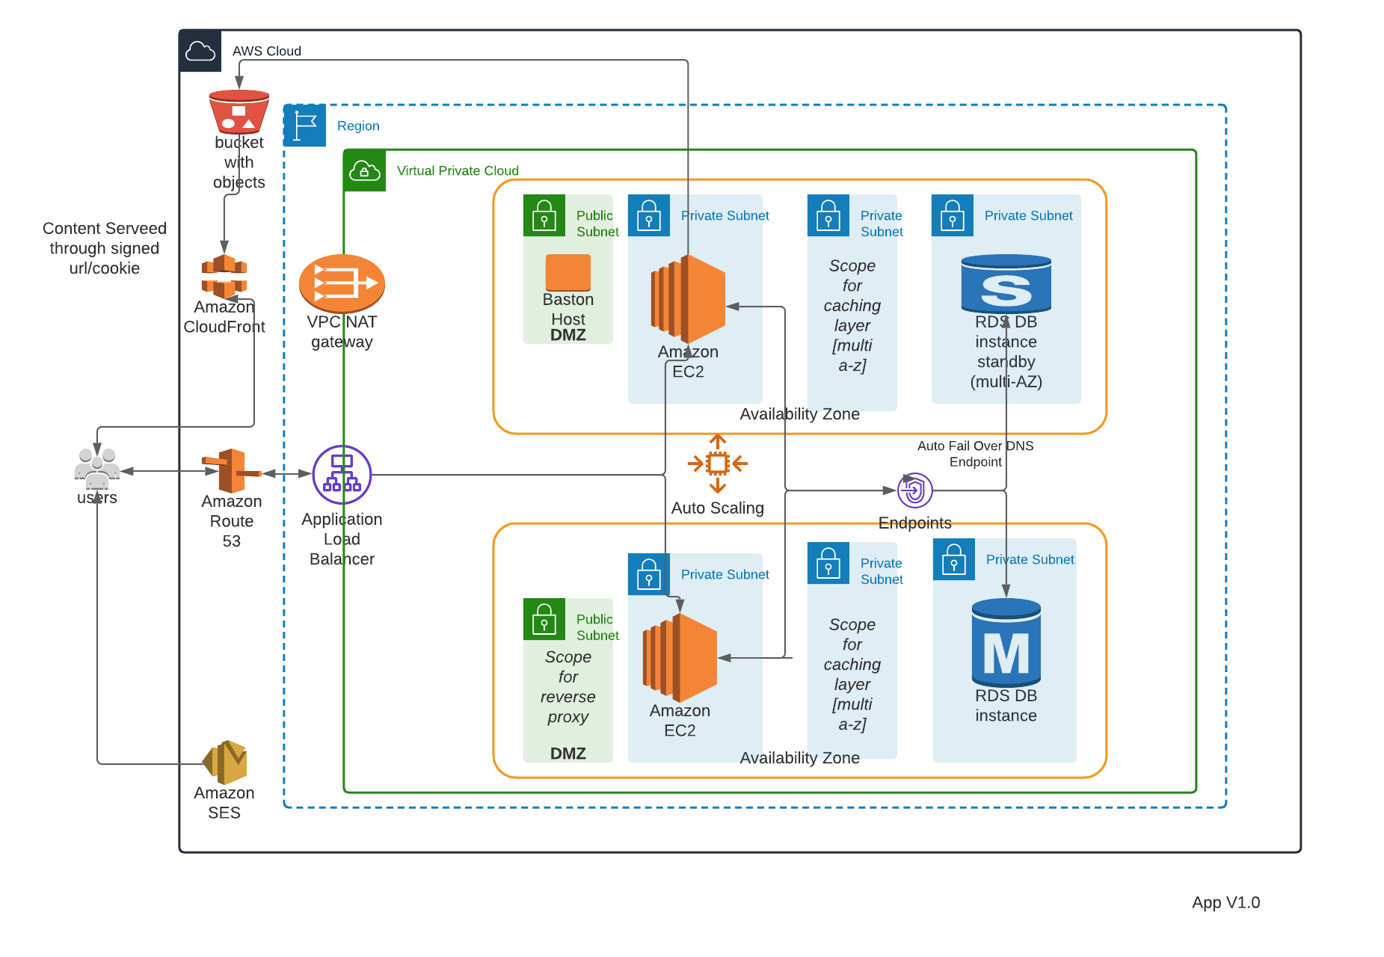

Figure 1: Architecture used to create AI/ML ecosystem for Model X

The figure should be referred to in the text of the document using **References->Cross-reference** ([see video guide](https://www.youtube.com/watch?v=0gFt18TL7as)) in the Word toolbar, using only label and number e.g., Figure 1. All such cross-references should be generated automatically in this way.

# Model Description

Provide a description of the AI/ML code and data that you used in the context of your problem under consideration. Describe how you deployed it to the cloud. Provide results from the model including relevant KPIs, performance diagrams and results of experiments. Performance diagrams should be captioned and referenced in the same manner as the architecture diagram.

If you have not created the associated code yourself then provide full attribution using **Citations and References** ([explained in this video tutorial](https://www.youtube.com/watch?v=CnVq_BpwP2E)) and insert the References at the end as indicated in the video.

You must demonstrate that your code ran in the architecture you provided.

You must also submit your code with your submission as a ZIP file.

# Scalability Considerations

This section is an opportunity to demonstrate your understanding of the workings of AI Ecosystems for the scalability of your application. What must be considered for the scalability of your application should any aspect of it scale and how would you approach this? Provide examples based on your application.

You **must** draw on the topics considered under the AWS Cloud Foundations and AWS ML content taught this semester, with **specific considerations about your application** provided in the context of **specific citations of the actual material provided in class by the module leader through Brightspace**, e.g., (Patrick Denny, 2024) and in a similar manner to any AWS Documentation references. Use Citations and References ([explained in this video tutorial](https://www.youtube.com/watch?v=CnVq_BpwP2E)) to do this and insert the References at the end as indicated in the video. These will all then show up automatically in the references section, where it will be possible for a person registered to the module to observe them.

You can make references to diagrams in the class material but cannot reproduce the diagrams in your submission.

You can provide diagrams that you have created yourself.

Attribution must be given to all unoriginal content used by the author.

The Assignment shall be no longer than 10 pages in total, not including the cover page and automatically generated References section. The document shall be submitted as a PDF.

# References

Patrick Denny. (2024, February 26). *AWS Cloud Security - Tuesday Week 4 Material.* Retrieved from CS5024 - Theory and Practice of Advanced AI Ecosystems: https://learn.ul.ie/d2l/le/lessons/17937/topics/634587